HTML Script Element

📘 Definition
# Source: AI Source: Provided by: [Data Path: Persons Table -> ID Column: 1, Name_En Column: Motasem Essam] -> From: [ChatGPT] on [5/6/2026]
The <script> element is used to add JavaScript code to an HTML page.
It allows you to make your webpage interactive and dynamic.
It can control and change almost everything on a webpage.

🎯 Interactive Vs Dynamic

🖱️ 1. Interactive

📖 Meaning:
# Source: AI Source: Provided by: [Data Path: Persons Table -> ID Column: 1, Name_En Column: Motasem Essam] -> From: [ChatGPT] on [5/6/2026]
A webpage is interactive when the user can do something and the page responds.
👉 There is user action → immediate response

🧠 Example of Interactive
# Source: AI Source: Provided by: [Data Path: Persons Table -> ID Column: 1, Name_En Column: Motasem Essam] -> From: [ChatGPT] on [5/6/2026]
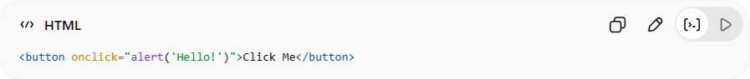
<button onclick="alert('Hello!')">Click Me</button>
👉 What happens:
- User clicks the button
- Page responds with a message
✔ User is involved
✔ Action triggers reaction

🔍 More interactive examples
# Source: AI Source: Provided by: [Data Path: Persons Table -> ID Column: 1, Name_En Column: Motasem Essam] -> From: [ChatGPT] on [5/6/2026]
- Clicking a button
- Filling a form
- Hovering over elements
- Playing a video

⚡ 2. Dynamic

📖 Meaning:
# Source: AI Source: Provided by: [Data Path: Persons Table -> ID Column: 1, Name_En Column: Motasem Essam] -> From: [ChatGPT] on [5/6/2026]
A webpage is dynamic when its content changes automatically or programmatically, not fixed like static HTML.
👉 Content is generated or updated, often without reloading the page

🧠 Example of Dynamic
# Source: AI Source: Provided by: [Data Path: Persons Table -> ID Column: 1, Name_En Column: Motasem Essam] -> From: [ChatGPT] on [5/6/2026]
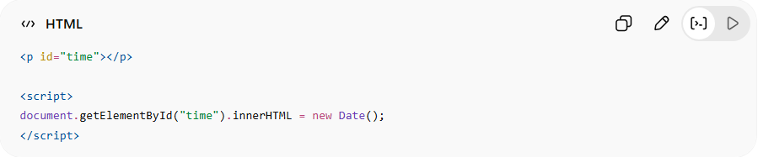
<p id="time"></p>
<script>
document.getElementById("time").innerHTML = new Date();
</script>
👉 What happens:
- Page shows current time
- Content is generated by JavaScript
✔ Changes over time
✔ Not hardcoded

🔍 More dynamic examples
# Source: AI Source: Provided by: [Data Path: Persons Table -> ID Column: 1, Name_En Column: Motasem Essam] -> From: [ChatGPT] on [5/6/2026]
- Live clock ⏰
- Loading new data from server 🌐
- Updating content without refresh
- Showing/hiding elements automatically

⚖️ Key Difference
# Source: AI Source: Provided by: [Data Path: Persons Table -> ID Column: 1, Name_En Column: Motasem Essam] -> From: [ChatGPT] on [5/6/2026]
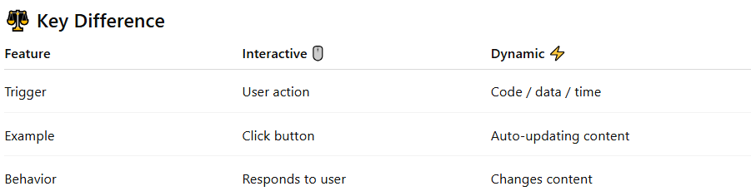
Feature | Interactive 🖱️ | Dynamic ⚡
Trigger | User action | Code / data / time
Example | Click button | Auto-updating content
Behavior | Responds to user | Changes content

Trigger:
# Source: AI Source: Provided by: [Data Path: Persons Table -> ID Column: 1, Name_En Column: Motasem Essam] -> From: [ChatGPT] on [5/6/2026]
In this context, a trigger is the thing that starts or causes something to happen.
👉 Think of it as:
“What makes the action happen?”

🖱️ Trigger in Interactive
# Source: AI Source: Provided by: [Data Path: Persons Table -> ID Column: 1, Name_En Column: Motasem Essam] -> From: [ChatGPT] on [5/6/2026]
Trigger = User action
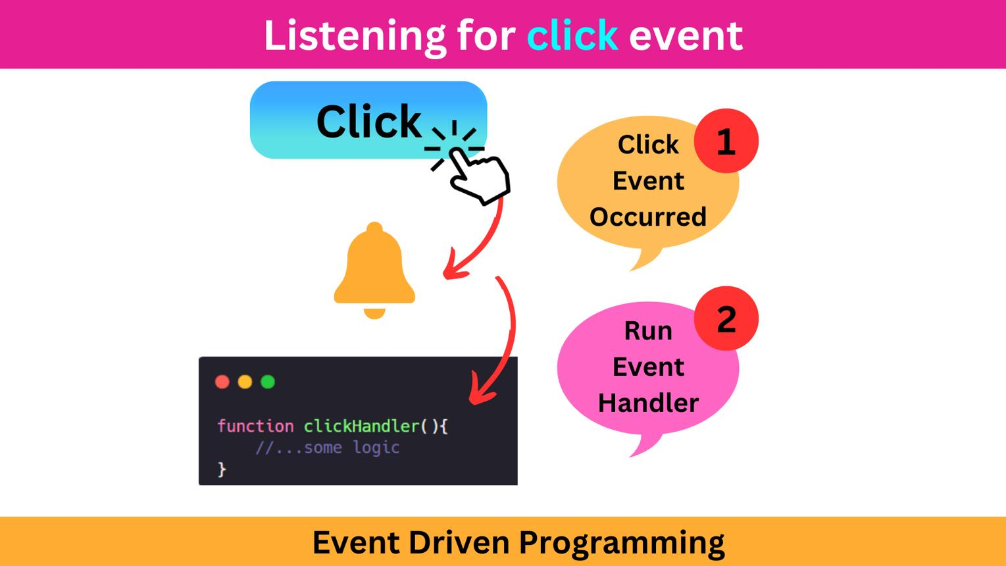
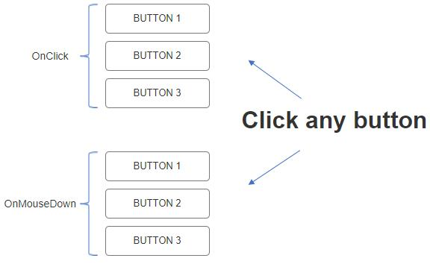
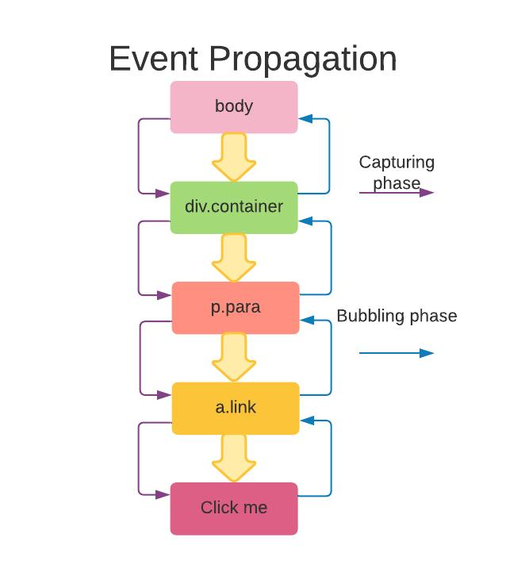
🧠 Example:
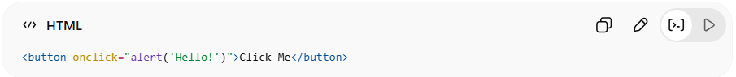
<button onclick="alert('Hello!')">Click Me</button>
👉 Trigger = user clicks the button
👉 Result = alert appears
✔ Trigger comes from the user

⚡ Trigger in Dynamic
# Source: AI Source: Provided by: [Data Path: Persons Table -> ID Column: 1, Name_En Column: Motasem Essam] -> From: [ChatGPT] on [5/6/2026]
Trigger = Code / system / data
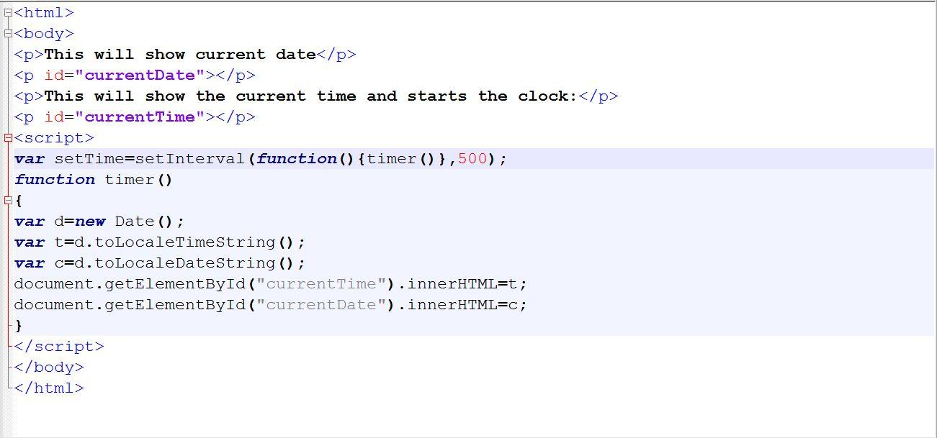
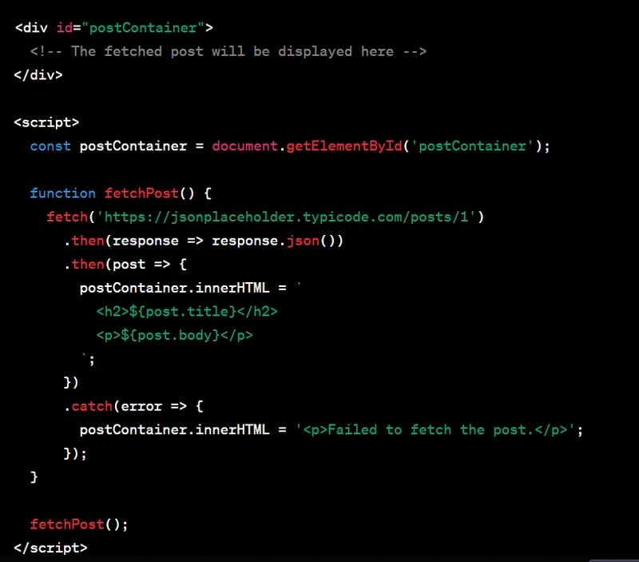
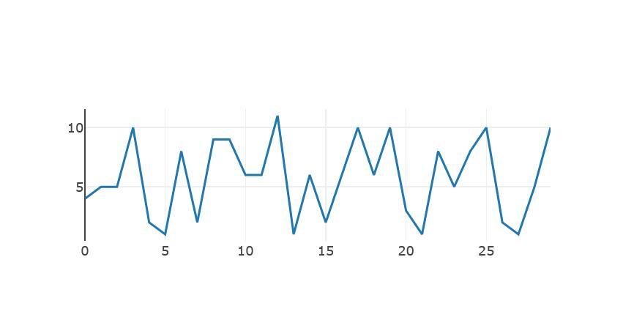
🧠 Example:
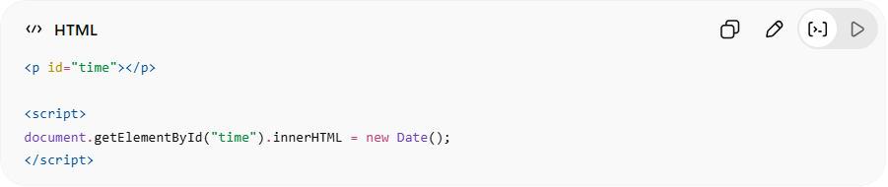
<p id="time"></p>
<script>
document.getElementById("time").innerHTML = new Date();
</script>
👉 Trigger = JavaScript code runs automatically
👉 Result = time appears
✔ Trigger comes from the system/code, not the user

⚖️ Simple comparison
# Source: AI Source: Provided by: [Data Path: Persons Table -> ID Column: 1, Name_En Column: Motasem Essam] -> From: [ChatGPT] on [5/6/2026]
- 🖱️ Interactive trigger → user does something
- ⚡ Dynamic trigger → system/code does something

🧠 Simple analogy
# Source: AI Source: Provided by: [Data Path: Persons Table -> ID Column: 1, Name_En Column: Motasem Essam] -> From: [ChatGPT] on [5/6/2026]
- 🔫 “Trigger” like in a tool:
→ You press it → something happens
- 🎮 In websites:
→ Click / load / data → something happens

🚀 Final Answer
# Source: AI Source: Provided by: [Data Path: Persons Table -> ID Column: 1, Name_En Column: Motasem Essam] -> From: [ChatGPT] on [5/6/2026]
Trigger = the event or action that causes something to happen on a webpage.

🧠 Simple analogy
# Source: AI Source: Provided by: [Data Path: Persons Table -> ID Column: 1, Name_En Column: Motasem Essam] -> From: [ChatGPT] on [5/6/2026]
- 🎮 Interactive = you press a button → game reacts
- 📺 Dynamic = content changes automatically (like live TV)

🚀 Final Answer
# Source: AI Source: Provided by: [Data Path: Persons Table -> ID Column: 1, Name_En Column: Motasem Essam] -> From: [ChatGPT] on [5/6/2026]
- Interactive = user controls the page
- Dynamic = the page updates or changes content automatically

🚀 Common Things JavaScript Can Do

🖱️ 1. Respond to User Actions
# Source: AI Source: Provided by: [Data Path: Persons Table -> ID Column: 1, Name_En Column: Motasem Essam] -> From: [ChatGPT] on [5/6/2026]
📖 Description:
JavaScript can react when users click, type, hover, scroll, etc.
💻 Example:
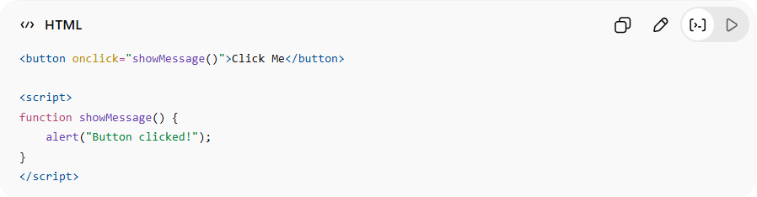
<button onclick="showMessage()">Click Me</button>

<script>
function showMessage() {
alert("Button clicked!");
}
</script>
👉 When user clicks → popup appears

📝 2. Change HTML Content
# Source: AI Source: Provided by: [Data Path: Persons Table -> ID Column: 1, Name_En Column: Motasem Essam] -> From: [ChatGPT] on [5/6/2026]
📖 Description:
JavaScript can modify webpage text and elements dynamically.
💻 Example:
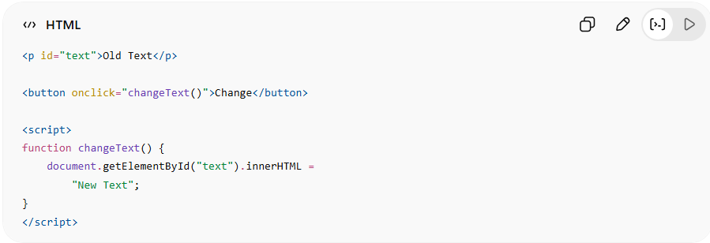
<p id="text">Old Text</p>

<button onclick="changeText()">Change</button>

<script>
function changeText() {
document.getElementById("text").innerHTML =
"New Text";
}
</script>
👉 Changes webpage content instantly

🏷️ 3. Change HTML Attributes
# Source: AI Source: Provided by: [Data Path: Persons Table -> ID Column: 1, Name_En Column: Motasem Essam] -> From: [ChatGPT] on [5/6/2026]
📖 Description:
JavaScript can change HTML attributes like:
- src
- href
- class
- alt
- value
💻 Example:
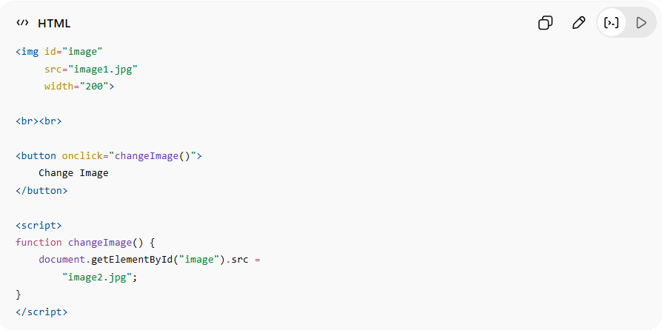
<img id="image"
src="image1.jpg"
width="200">

<br><br>

<button onclick="changeImage()">
Change Image
</button>

<script>
function changeImage() {
document.getElementById("image").src =
"image2.jpg";
}
</script>
👉 Changes image dynamically

🎨 4. Change CSS Styles
# Source: AI Source: Provided by: [Data Path: Persons Table -> ID Column: 1, Name_En Column: Motasem Essam] -> From: [ChatGPT] on [5/6/2026]
📖 Description:
JavaScript can change colors, fonts, layouts, animations, and more.
💻 Example:
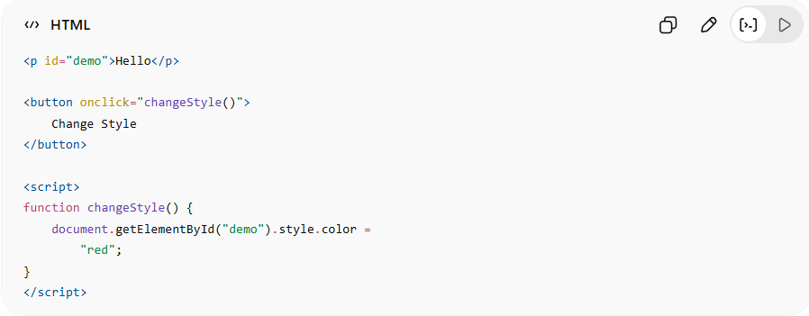
<p id="demo">Hello</p>

<button onclick="changeStyle()">
Change Style
</button>

<script>
function changeStyle() {
document.getElementById("demo").style.color =
"red";
}
</script>
👉 Changes element appearance dynamically

🧾 5. Validate Forms
# Source: AI Source: Provided by: [Data Path: Persons Table -> ID Column: 1, Name_En Column: Motasem Essam] -> From: [ChatGPT] on [5/6/2026]
📖 Description:
Checks user input before sending data.
💻 Example:
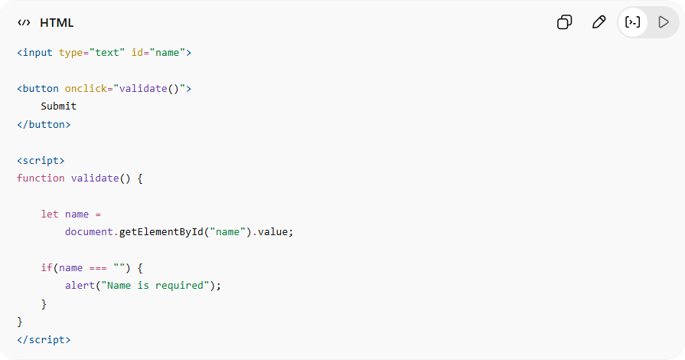
<input type="text" id="name">

<button onclick="validate()">
Submit
</button>

<script>
function validate() {

let name =
document.getElementById("name").value;

if(name === "") {
alert("Name is required");
}
}
</script>
👉 Prevents invalid form submission

🎞️ 6. Create Animations
# Source: AI Source: Provided by: [Data Path: Persons Table -> ID Column: 1, Name_En Column: Motasem Essam] -> From: [ChatGPT] on [5/6/2026]
📖 Description:
JavaScript can move and animate elements.
💻 Example:
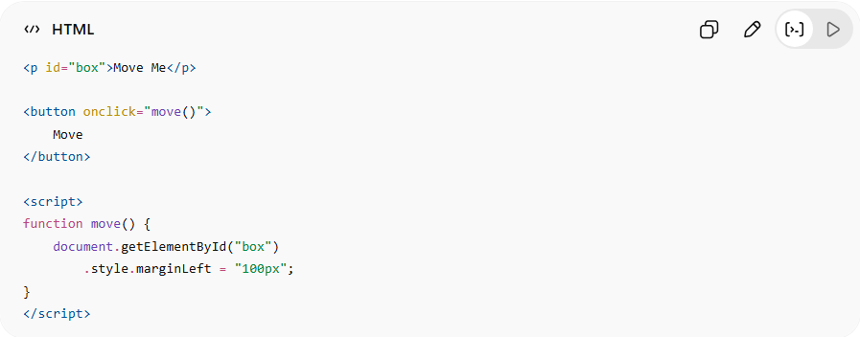
<p id="box">Move Me</p>

<button onclick="move()">
Move
</button>

<script>
function move() {
document.getElementById("box")
.style.marginLeft = "100px";
}
</script>
👉 Moves element on screen

🌐 7. Load Data Without Refreshing
# Source: AI Source: Provided by: [Data Path: Persons Table -> ID Column: 1, Name_En Column: Motasem Essam] -> From: [ChatGPT] on [5/6/2026]
📖 Description:
JavaScript can update webpage data dynamically.
💻 Example:
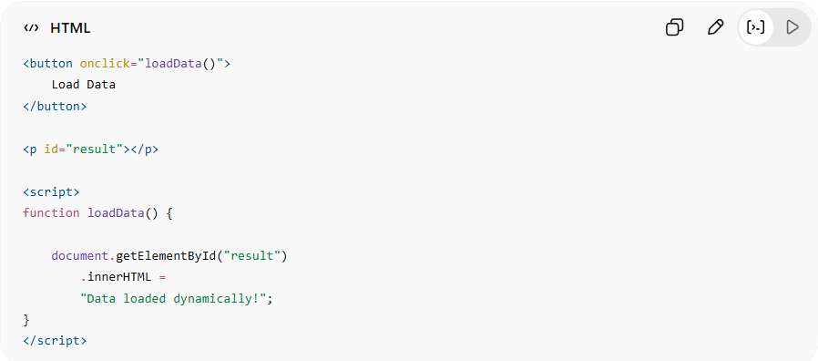
<button onclick="loadData()">
Load Data
</button>

<p id="result"></p>

<script>
function loadData() {

document.getElementById("result")
.innerHTML =
"Data loaded dynamically!";
}
</script>
👉 Content changes without page reload

⏰ 8. Work With Time and Dates
# Source: AI Source: Provided by: [Data Path: Persons Table -> ID Column: 1, Name_En Column: Motasem Essam] -> From: [ChatGPT] on [5/6/2026]
📖 Description:
JavaScript can display clocks, timers, and dates.
💻 Example:
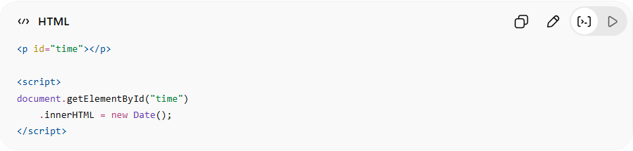
<p id="time"></p>

<script>
document.getElementById("time")
.innerHTML = new Date();
</script>
👉 Displays current date and time

🔊 9. Control Media
# Source: AI Source: Provided by: [Data Path: Persons Table -> ID Column: 1, Name_En Column: Motasem Essam] -> From: [ChatGPT] on [5/6/2026]
📖 Description:
JavaScript can play, pause, and control audio/video.
💻 Example:
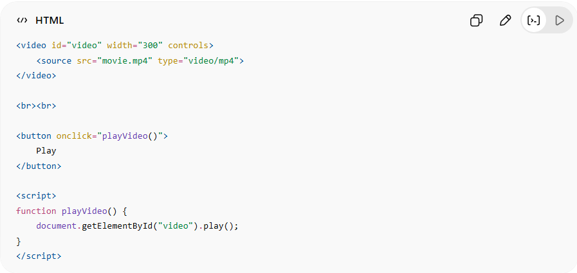
<video id="video" width="300" controls>
<source src="movie.mp4" type="video/mp4">
</video>

<br><br>

<button onclick="playVideo()">
Play
</button>

<script>
function playVideo() {
document.getElementById("video").play();
}
</script>
👉 Controls video dynamically

🧮 10. Perform Calculations
# Source: AI Source: Provided by: [Data Path: Persons Table -> ID Column: 1, Name_En Column: Motasem Essam] -> From: [ChatGPT] on [5/6/2026]
📖 Description:
JavaScript can calculate values and process logic.
💻 Example:
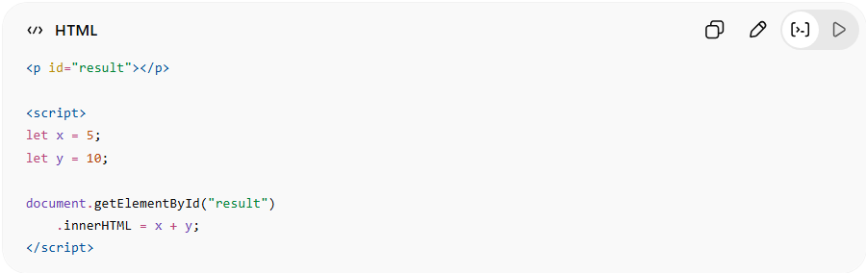
<p id="result"></p>

<script>
let x = 5;
let y = 10;

document.getElementById("result")
.innerHTML = x + y;
</script>
👉 Performs mathematical operations

🎮 11. Build Games and Applications
# Source: AI Source: Provided by: [Data Path: Persons Table -> ID Column: 1, Name_En Column: Motasem Essam] -> From: [ChatGPT] on [5/6/2026]
📖 Description:
JavaScript can create:
- Games
- Web apps
- Interactive tools
- Chat systems
💻 Example:
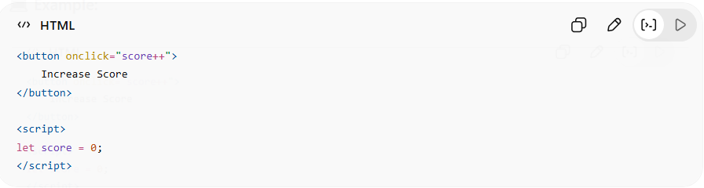
<button onclick="score++">
Increase Score
</button>

<script>
let score = 0;
</script>
👉 Basic game interaction logic

⚙️ Key Abilities of JavaScript
# Source: AI Source: Provided by: [Data Path: Persons Table -> ID Column: 1, Name_En Column: Motasem Essam] -> From: [ChatGPT] on [5/6/2026]
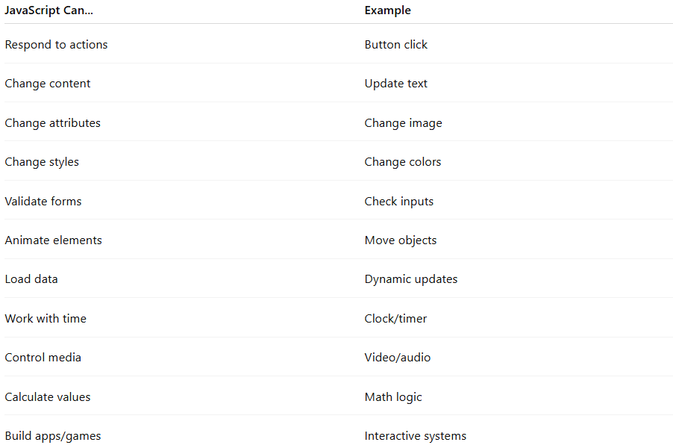
JavaScript Can... | Example
Respond to actions | Button click
Change content | Update text
Change attributes | Change image
Change styles | Change colors
Validate forms | Check inputs
Animate elements | Move objects
Load data | Dynamic updates
Work with time | Clock/timer
Control media | Video/audio
Calculate values | Math logic
Build apps/games | Interactive systems

🚀 In short:
# Source: AI Source: Provided by: [Data Path: Persons Table -> ID Column: 1, Name_En Column: Motasem Essam] -> From: [ChatGPT] on [5/6/2026]
JavaScript controls webpage behavior, adds interactivity, updates content dynamically, and powers modern web applications.

⚙️ How <script> works
# Source: AI Source: Provided by: [Data Path: Persons Table -> ID Column: 1, Name_En Column: Motasem Essam] -> From: [ChatGPT] on [5/6/2026]
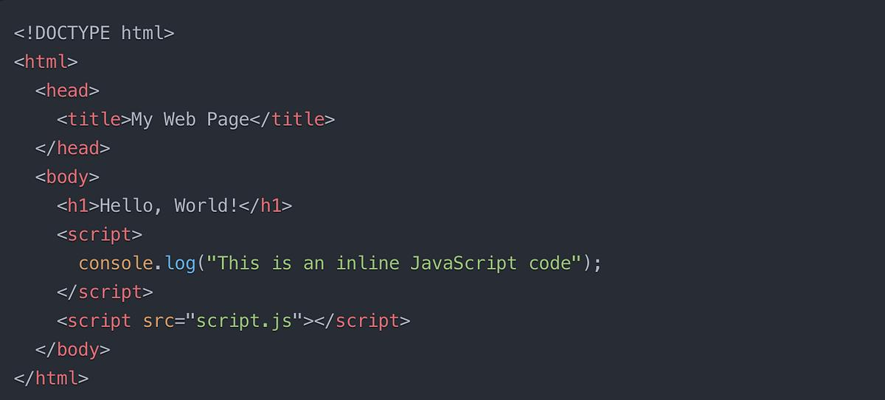
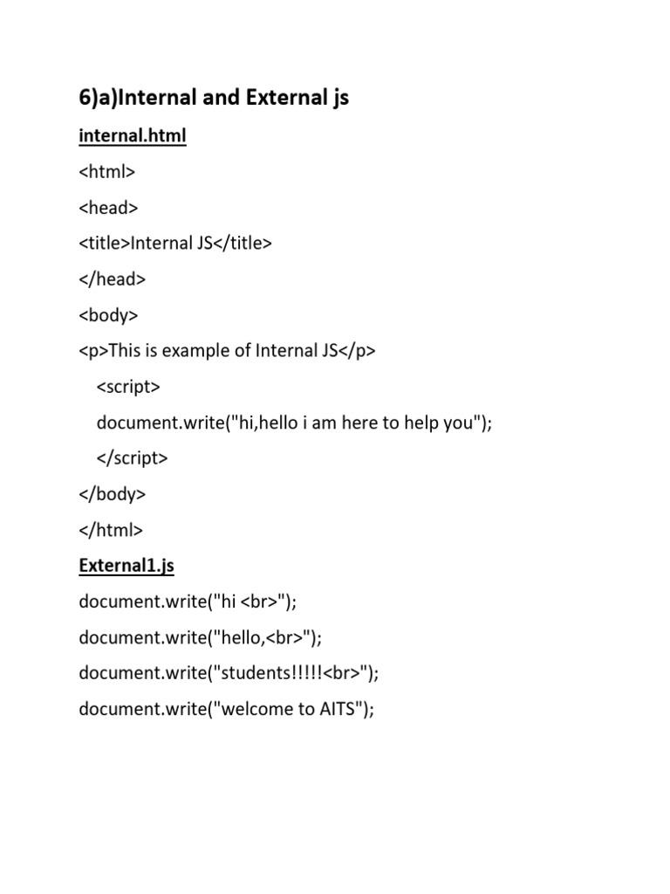
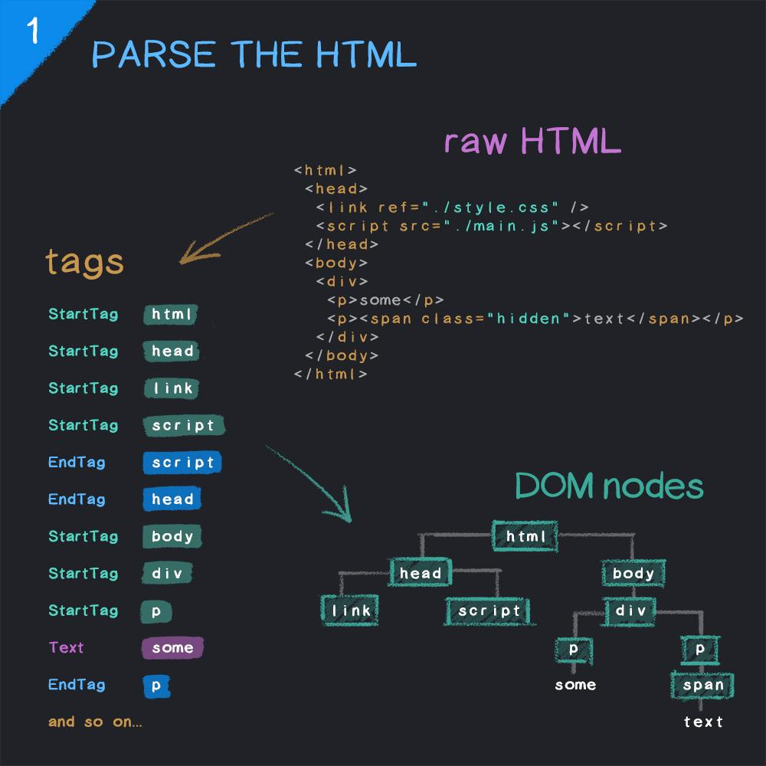
- The browser reads HTML
- When it finds <script>, it executes JavaScript
- JavaScript can change content, style, or behavior

🧪 <script> (with examples)

🟢 1. Internal JavaScript
# Source: AI Source: Provided by: [Data Path: Persons Table -> ID Column: 1, Name_En Column: Motasem Essam] -> From: [ChatGPT] on [5/6/2026]
📖 Description:
Write JavaScript directly inside the HTML file.
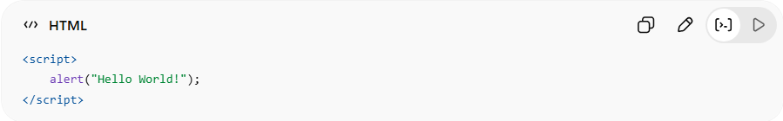
<script>
alert("Hello World!");
</script>
👉 Shows a popup message when the page loads

Full Example
# Source: AI Source: Provided by: [Data Path: Persons Table -> ID Column: 1, Name_En Column: Motasem Essam] -> From: [ChatGPT] on [5/6/2026]
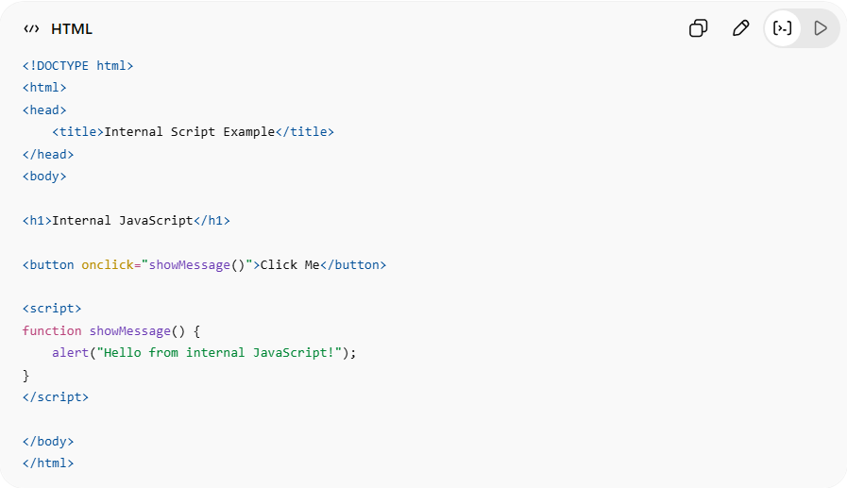
<!DOCTYPE html>
<html>
<head>
<title>Internal Script Example</title>
</head>
<body>

<h1>Internal JavaScript</h1>

<button onclick="showMessage()">Click Me</button>

<script>
function showMessage() {
alert("Hello from internal JavaScript!");
}
</script>

</body>
</html>

Real Example
# Source: ScreenShot Source: Provided by: [Persons Table -> ID Column: 1, Name_En Column: Motasem Essam] -> Tool: [Automation Table -> ID Column: 16, Name_En Column: Screen Capture] -> From [Operating System: Windows] on [5/6/2026]
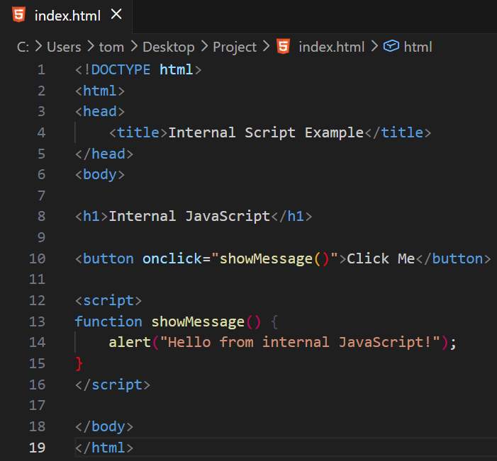
<!DOCTYPE html>
<html>
<head>
<title>Internal Script Example</title>
</head>
<body>

<h1>Internal JavaScript</h1>

<button onclick="showMessage()">Click Me</button>

<script>
function showMessage() {
alert("Hello from internal JavaScript!");
}
</script>

</body>
</html>
# Source: GIF Source: Provided by: [Persons Table -> ID Column: 1, Name_En Column: Motasem Essam] -> Tool: [Automation Table -> ID Column: 17, Name_En Column: GIF Recorder] -> From [Operating System: Windows] on [5/6/2026]


🟡 2. External JavaScript File
# Source: AI Source: Provided by: [Data Path: Persons Table -> ID Column: 1, Name_En Column: Motasem Essam] -> From: [ChatGPT] on [5/6/2026]
📖 Description:
Link a separate .js file (best practice).
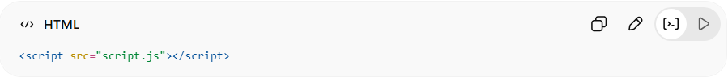
<script src="script.js"></script>
script.js
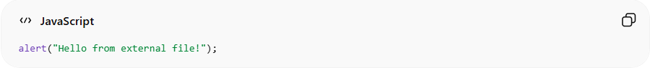
alert("Hello from external file!");
👉 Keeps HTML clean and organized

Full Example
# Source: AI Source: Provided by: [Data Path: Persons Table -> ID Column: 1, Name_En Column: Motasem Essam] -> From: [ChatGPT] on [5/6/2026]
📄 index.html
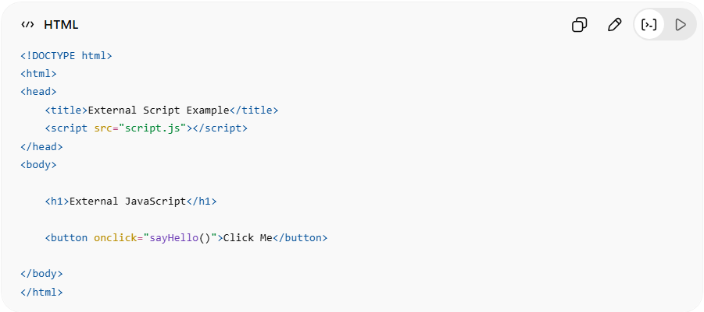
<!DOCTYPE html>
<html>
<head>
<title>External Script Example</title>
<script src="script.js"></script>
</head>
<body>
<h1>External JavaScript</h1>
<button onclick="sayHello()">Click Me</button>
</body>
</html>

📄 script.js
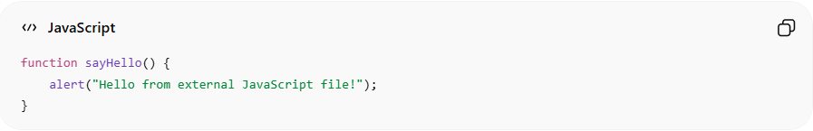
function sayHello() {
alert("Hello from external JavaScript file!");
}

Real Example
# Source: ScreenShot Source: Provided by: [Persons Table -> ID Column: 1, Name_En Column: Motasem Essam] -> Tool: [Automation Table -> ID Column: 16, Name_En Column: Screen Capture] -> From [Operating System: Windows] on [5/6/2026]
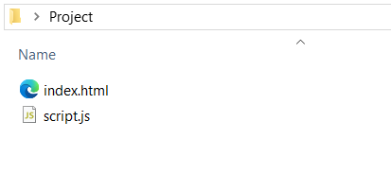
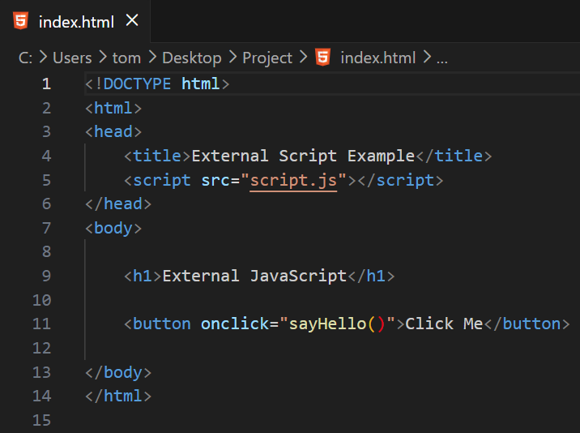
<!DOCTYPE html>
<html>
<head>
<title>External Script Example</title>
<script src="script.js"></script>
</head>
<body>

<h1>External JavaScript</h1>

<button onclick="sayHello()">Click Me</button>

</body>
</html>
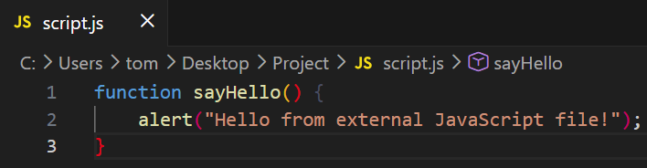
function sayHello() {
alert("Hello from external JavaScript file!");
}

# Source: GIF Source: Provided by: [Persons Table -> ID Column: 1, Name_En Column: Motasem Essam] -> Tool: [Automation Table -> ID Column: 17, Name_En Column: GIF Recorder] -> From [Operating System: Windows] on [5/6/2026]


Script in <head> vs <body>
# Source: AI Source: Provided by: [Data Path: Persons Table -> ID Column: 1, Name_En Column: Motasem Essam] -> From: [ChatGPT] on [5/6/2026]
Script runs after HTML loads (faster page load).

Script in <head>
# Source: AI Source: Provided by: [Data Path: Persons Table -> ID Column: 1, Name_En Column: Motasem Essam] -> From: [ChatGPT] on [5/6/2026]
When JavaScript is placed inside <head>, the browser usually stops building the HTML page until the script is downloaded and executed.
Example:
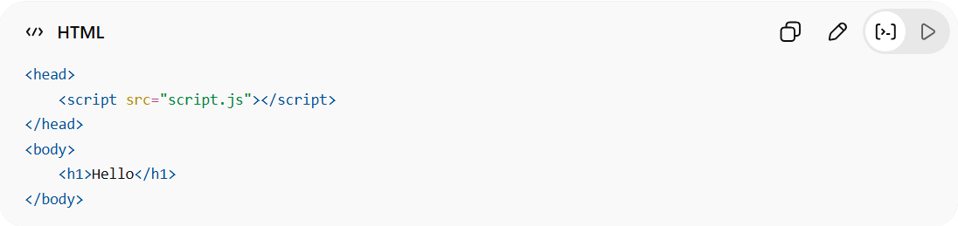
<head>
<script src="script.js"></script>
</head>
<body>
<h1>Hello</h1>
</body>
What happens:
- Browser starts reading HTML.
- Browser reaches <script>.
- Browser pauses HTML parsing.
- Downloads script.js.
- Executes the script.
- Continues reading the rest of the HTML.
So the page content (<h1>Hello</h1>) appears later.
This is called render blocking because the script blocks page rendering.

Script in <body>
# Source: AI Source: Provided by: [Data Path: Persons Table -> ID Column: 1, Name_En Column: Motasem Essam] -> From: [ChatGPT] on [5/6/2026]
When the script is placed at the end of <body>:
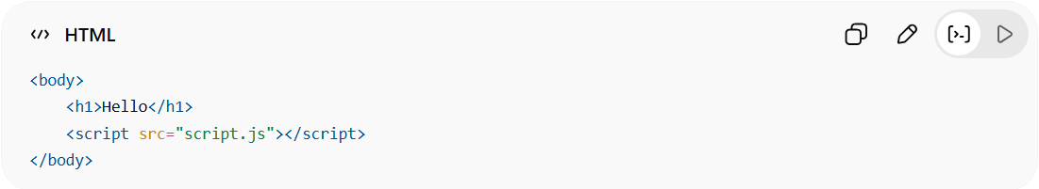
<body>
<h1>Hello</h1>
<script src="script.js"></script>
</body>

What happens:
- Browser reads and builds most of the HTML first.
- Page content becomes visible quickly.
- Browser reaches the script near the end.
- Downloads and runs JavaScript.
So, users see the page faster.

JavaScript often accesses HTML elements
# Source: AI Source: Provided by: [Data Path: Persons Table -> ID Column: 1, Name_En Column: Motasem Essam] -> From: [ChatGPT] on [5/6/2026]
JavaScript often accesses HTML elements.
Example:
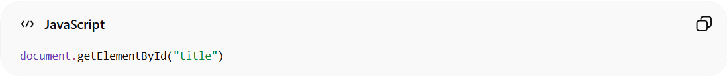
document.getElementById("title")

If the script runs before the HTML element exists, it may fail.
Bad example:
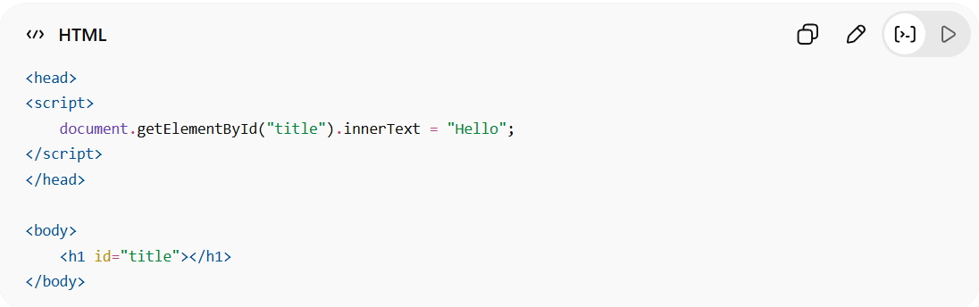
<head>
<script>
document.getElementById("title").innerText = "Hello";
</script>
</head>
<body>
<h1 id="title"></h1>
</body>
#title does not exist yet when the script runs.

But at the end of <body>:
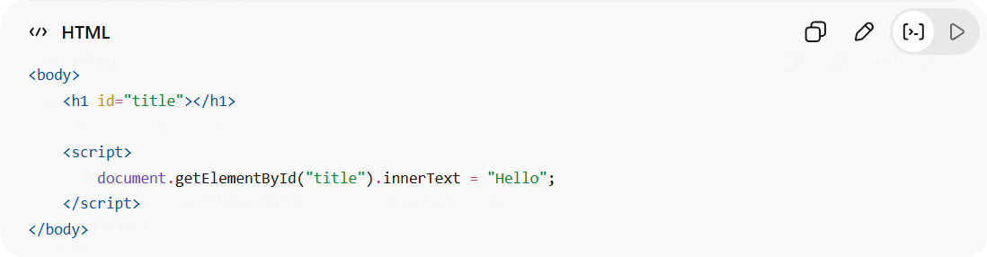
<body>
<h1 id="title"></h1>

<script>
document.getElementById("title").innerText = "Hello";
</script>
</body>
Now the element already exists, so it works.

Using defer (Best Practice)
# Source: AI Source: Provided by: [Data Path: Persons Table -> ID Column: 1, Name_En Column: Motasem Essam] -> From: [ChatGPT] on [5/6/2026]
📖 Description:
Loads script in background and runs after HTML is ready.
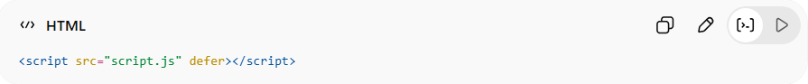
<script src="script.js" defer></script>
👉 Best for performance and clean loading

You can safely put scripts in <head> using defer:
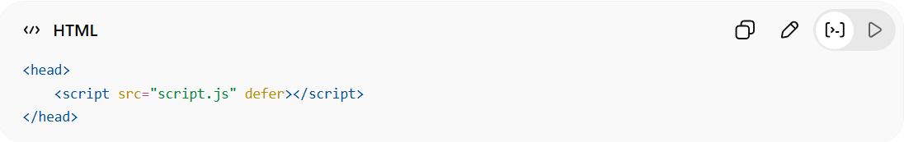
<head>
<script src="script.js" defer></script>
</head>
defer means:
- Download script while HTML loads
- Execute script after HTML parsing finishes
This gives both:
- organized <head>
- fast loading behavior

Using async
# Source: AI Source: Provided by: [Data Path: Persons Table -> ID Column: 1, Name_En Column: Motasem Essam] -> From: [ChatGPT] on [5/6/2026]
📖 Description:
Loads and runs script independently (faster but unordered).
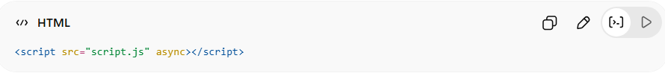
<script src="script.js" async></script>
👉 Good for analytics or ads

async is another way to load JavaScript without blocking HTML parsing completely.
Example:
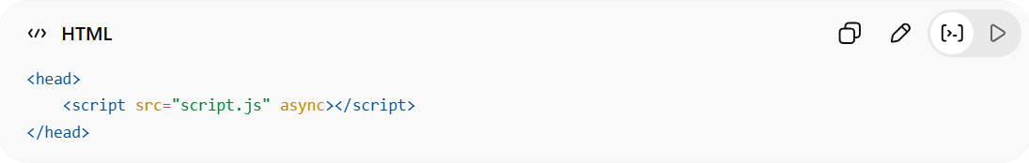
<head>
<script src="script.js" async></script>
</head>

How async works:
- Browser reads HTML
- Browser starts downloading script in background
- HTML parsing continues
- When script finishes downloading:
  - HTML parsing pauses
  - Script executes immediately
- HTML parsing resumes

Important difference
With async, this can fail:
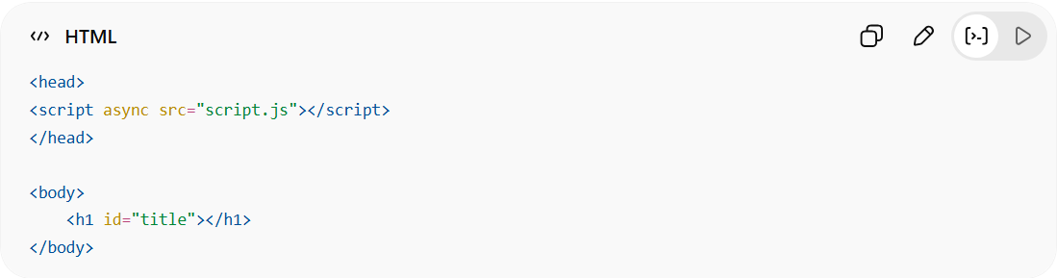
<head>
<script async src="script.js"></script>
</head>

<body>
<h1 id="title"></h1>
</body>

If script.js runs before <h1> loads:
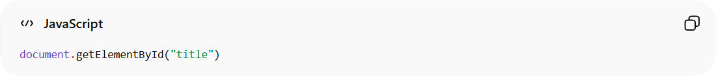
document.getElementById("title")
returns:
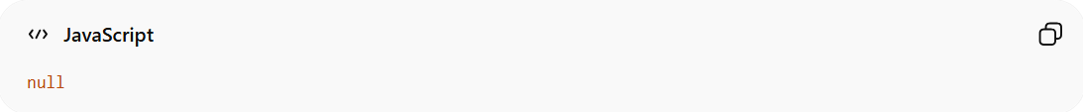
Null
because the element is not created yet.

async vs defer

async
# Source: AI Source: Provided by: [Data Path: Persons Table -> ID Column: 1, Name_En Column: Motasem Essam] -> From: [ChatGPT] on [5/6/2026]
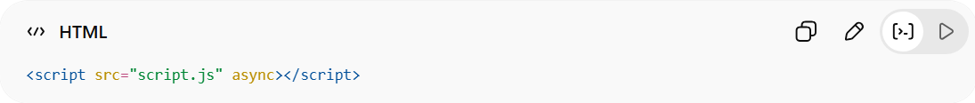
<script src="script.js" async></script>
- Downloads in background
- Executes immediately when ready
- May execute before HTML finishes loading
- Order between scripts is NOT guaranteed
Good for:
- analytics
- ads
- independent scripts

Defer
# Source: AI Source: Provided by: [Data Path: Persons Table -> ID Column: 1, Name_En Column: Motasem Essam] -> From: [ChatGPT] on [5/6/2026]
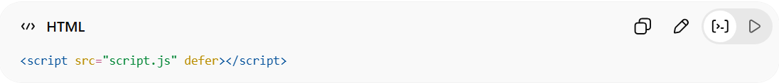
<script src="script.js" defer></script>
- Downloads in background
- Waits until HTML parsing finishes
- Executes before DOMContentLoaded
- Keeps script order
Good for:
- most website scripts
- DOM manipulation

Visual Timeline

Normal script
# Source: AI Source: Provided by: [Data Path: Persons Table -> ID Column: 1, Name_En Column: Motasem Essam] -> From: [ChatGPT] on [5/6/2026]
HTML ----STOP---- Script ---- Continue HTML
Description
Browser stops reading HTML when it reaches the script.
Script is downloaded and executed immediately, then HTML parsing continues.
Can slow page loading because it blocks rendering.

Async
# Source: AI Source: Provided by: [Data Path: Persons Table -> ID Column: 1, Name_En Column: Motasem Essam] -> From: [ChatGPT] on [5/6/2026]
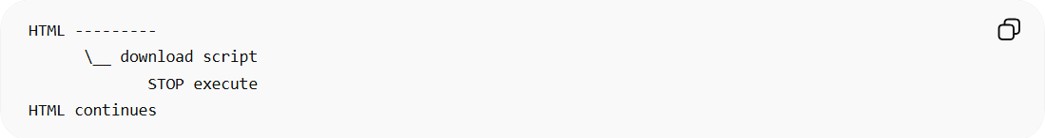
HTML ---------
\__ download script
STOP execute
HTML continues
Description:
Script downloads in the background while HTML continues loading.
When download finishes, browser pauses HTML parsing temporarily and executes the script immediately.
Execution order between multiple async scripts is not guaranteed.

defer
# Source: AI Source: Provided by: [Data Path: Persons Table -> ID Column: 1, Name_En Column: Motasem Essam] -> From: [ChatGPT] on [5/6/2026]
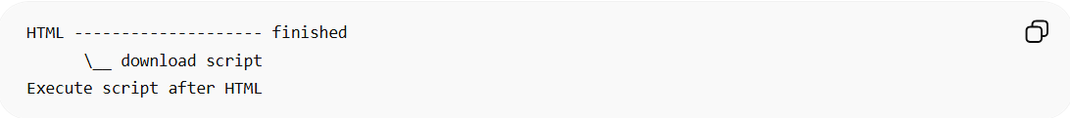
HTML -------------------- finished
\__ download script
Execute script after HTML
📖 Description:
Script downloads in the background while HTML loads.
Browser waits until all HTML parsing is complete before executing the script.
Recommended for most website scripts because it avoids blocking page rendering and preserves script order.

Recommended
# Source: AI Source: Provided by: [Data Path: Persons Table -> ID Column: 1, Name_En Column: Motasem Essam] -> From: [ChatGPT] on [5/6/2026]
For most websites:
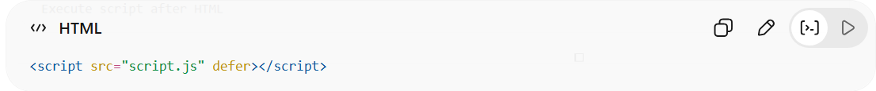
<script src="script.js" defer></script>
is usually the best choice.

⚠️ Common Mistakes
# Source: AI Source: Provided by: [Data Path: Persons Table -> ID Column: 1, Name_En Column: Motasem Essam] -> From: [ChatGPT] on [5/6/2026]
❌ Missing src file:
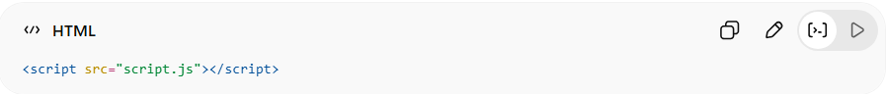
<script src="script.js"></script>
(if file doesn't exist → error)
❌ Blocking page loading:
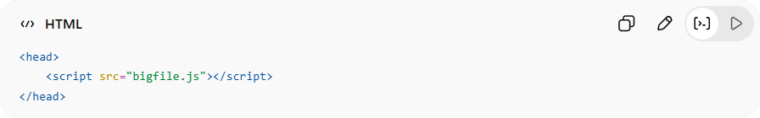
<head>
<script src="bigfile.js"></script>
</head>

⚙️ Key Features
# Source: AI Source: Provided by: [Data Path: Persons Table -> ID Column: 1, Name_En Column: Motasem Essam] -> From: [ChatGPT] on [5/6/2026]
- 💻 Runs JavaScript in browser
- ⚡ Makes pages interactive
- 🔗 Can link external files
- 🎯 Controls behavior of webpage

🚀 In short:
# Source: AI Source: Provided by: [Data Path: Persons Table -> ID Column: 1, Name_En Column: Motasem Essam] -> From: [ChatGPT] on [5/6/2026]
<script> = the HTML element used to run JavaScript and make webpages interactive.

